Communication problems after a stroke

This guide is for anyone supporting a stroke survivor with communication problems. You’ll find information on the different types of communication problem, as well as tips on supporting someone with their recovery, and a guide to having good conversations.

Need help with communication problems?

Our Helpline can give you ideas about how to get support. Call 0303 3033 100 or email helpline@stroke.org.uk. Our Helpline officers will give you time to speak and respond.

More information about stroke
We have information and practical tips on all aspects of stroke. Visit our website to read online or call our Helpline to request print copies. Some useful topics include:

- Emotional changes after stroke: stroke.org.uk/emotional-changes.
- Problems with memory and thinking (cognitive problems): stroke.org.uk/thinking.
- Information for carers: stroke.org.uk/caring.
- Vascular dementia stroke.org.uk/vascular-dementia.

What’s in this guide?
- How does a stroke affect communication?
- Language and the brain
- Types of communication problems
- Are there treatments that can help?
- Are there aids or equipment that can help?
- Tips to share with someone with aphasia
- Tips for family and friends
- A guide to good conversations
- Where to get help and information

How does a stroke affect communication?

When a stroke happens, it damages part of the brain. Language is controlled by several different areas of the brain working together. If part of the brain that supports language is damaged by a stroke, this can affect communication. Turn to the next section for more about language and the brain.

Communication problems are very common after a stroke. Around two thirds (2/3) of people have communication problems directly after a stroke, and around a third (1/3) will have long-term difficulties.

The impact of a stroke on communication is different for each individual. It depends on the size of the stroke and where it happened in the brain. With the right support, communication problems can improve.

They can vary over time – someone can have good days and bad days. If someone is feeling tired, lacking confidence or in a low mood it can make it harder to communicate. Being in a busy or noisy place can make it harder to concentrate and respond.

Box:

Other causes of communication problems
Communication problems can be due to other conditions affecting the brain, such as dementia, traumatic brain injury and brain tumours. If you need dedicated information and support for one of those conditions, turn to our list of external organisations ‘Where to get more help and information’ at the end of this guide.
Box ends.

How does this affect daily life?
Communication problems can affect all aspects of someone’s life. It can have a big impact on relationships with friends and family members. Many people tell us that they become isolated or feel lonely after a stroke because of their difficulties with communication, as well as the loss of confidence. Friendships can drop away if people find it too difficult to communicate or feel unsure what to do to help a friend.

Keeping in touch
Maintaining social networks can be a huge factor in someone’s recovery so it’s vital for the person to be supported in keeping in touch with others, and building new friendships.

Fatigue and a loss of confidence after a stroke can make it harder for someone to be motivated to do things like rehabilitation activities. They might avoid going out and being active. These are all important parts of recovery, and people tell us that doing things they enjoy, and creating a routine, really helps their wellbeing.

Remember that someone might need help to build up their motivation. For example, you can give encouragement, and offer practical support with rehabilitation. Learn more about supporting someone after a stroke at stroke.org.uk/caring or call our Helpline for print copies.

Language and the brain

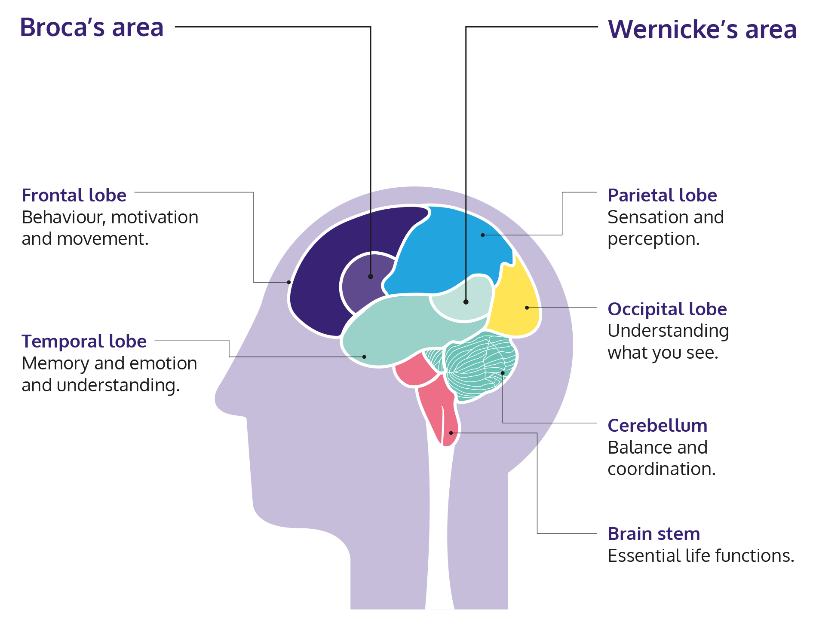
The left side of the brain contains the main language areas. But language is highly complex, and takes place in areas on both sides of the brain. Broca's and Wernicke's areas of the brain are important for language, but many other brain functions play a part in communication. These include memory, vision and concentration, as well as muscle control of mouth and voicebox.

How do we communicate?
When we communicate, our brain completes a series of tasks. When someone asks you a question, your brain has to understand what you are being asked, decide on your answer, put the words together and then reply.
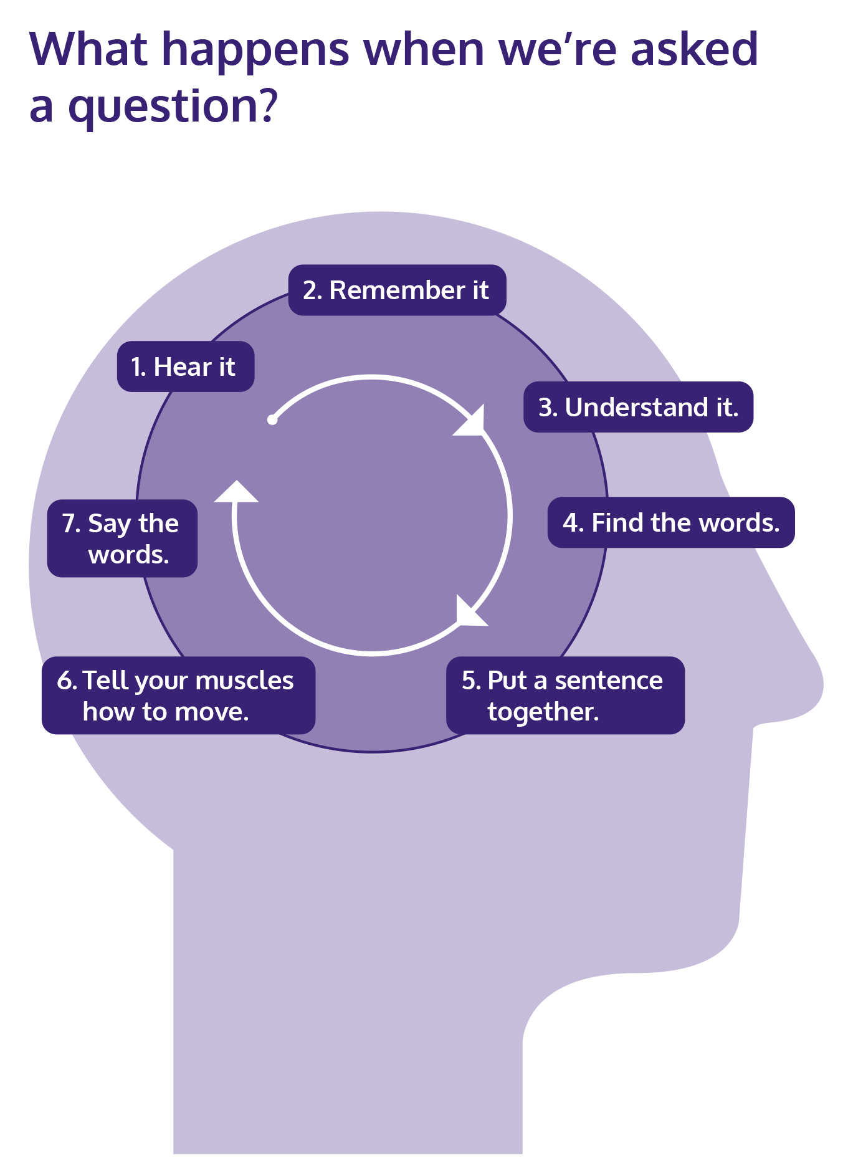
Different parts of the brain carry out these tasks. Depending on the area of the brain that is damaged, you could have problems with any part of this process. But, communication isn’t just about speaking and understanding speech. Many people also have problems with reading, writing, spelling and using numbers.

Communication problems can also be due to problems with moving or coordinating the muscles in your mouth and voice box, which can make it hard to speak and swallow. The voice box (also known as larynx) is near the top of your windpipe. It contains muscles that produce sound, and controls swallowing and breathing.

Concentration can also be affected, making it harder to follow a conversation. If someone has problems with memory and thinking (cognitive problems), they might find it hard to remember things, or understand ideas.

What happens when we’re asked a question?

Types of communication problems after stroke

Aphasia
Aphasia affects the ability to speak and understand what other people say. It can also affect reading, writing and using numbers, as well as using gestures and drawing pictures.
Aphasia is sometimes called dysphasia. Aphasia can be mild or more severe, and it can change over time. It happens when the parts of the brain that control language are damaged.

Aphasia is a common problem after stroke. About 1 in 4 people have it after a stroke.

Aphasia does not affect intelligence
If someone has aphasia it means they have problems with using language. It has nothing to do with intelligence, memory or thinking skills. However, someone may have cognitive problems as well as language difficulties, and they will need the right specialist support to help them recover and communicate.

Types of aphasia
There are different types of aphasia, and someone can have more than one type. They can be also have other problems with communication at the same time, such as dysarthria or cognitive problems. The most common types of aphasia are:

- Broca’s aphasia, also called non-fluent aphasia, is due to damage in ‘Broca’s area’ of the brain. It’s hard for someone to find the right words, but they may be able to understand speech quite well. They often know what they want to say, but can only say single words or very short sentences. This can feel frustrating to them and the person they are speaking to.

- Wernicke’s aphasia, also called receptive or fluent aphasia, is due to damage to ‘Wernicke’s area’ in the brain. It means someone can say words and sentences, but they often don’t make sense. They usually have trouble understanding speech. They may not know that what they are saying is unclear, so may get frustrated when people don’t understand them.

- Global aphasia is the most severe form of aphasia, and it’s due to damage in several language areas of the brain including Broca’s and Wernicke’s. It affects all aspects of language, making both speaking and understanding very difficult, even if the person’s memory and thinking skills are unaffected.

- Anomia, or anomic aphasia, is a milder form of aphasia. Someone can speak and use correct grammar, but they struggle to find the right word for things. They might substitute vague terms, or describe what an object does instead of using its name (such as a ‘jug for heating water’ instead of kettle).

Signs of aphasia
While it will be different for everyone, these are some of the more common signs of aphasia:

Problems with speech
- Not being able to form words, only sounds.
- Only being able to say single words or very short sentences, like “want drink”.
- Speaking slowly, with very long pauses.
- Missing out words or getting them in the wrong order.
- Getting stuck on a single word or sound, and repeating it over and over.
- Saying one word while meaning another, so they may say “milk” instead of “water”, or “yes” instead of “no”.
- Not being able to find the right word, even though they can describe what they are thinking of.
- Saying words and sentences that don’t make sense.

Problems understanding
- Not being able to fully understand what other people say.
- Finding it difficult to understand when there is background noise or many people talking at the same time in a group.
- Finding it difficult to follow a conversation on the phone, where you can’t see the other person’s face or body language.
- Having difficulty following instructions, and needing time to process what has been said.

Problems reading
- Being able to read only headlines in a newspaper but not the main text.
- Being able to write, but not able to read the words.
- Not recognising written words. This is sometimes called word blindness or visual aphasia.

Problems writing
- Difficulty forming letters and spelling words.
- Unable to write and type sentences in the right order, or unable to write at all.

Problems with numbers
- Problems understanding and using both written numbers (‘ten’) and digits (‘10’).
- Difficulty with calculations and understanding information with numbers.
- Problems with telling the time.

“Losing your communication doesn’t just affect you, it affects everyone around you too.” Chris

Dysarthria
Dysarthria happens when a stroke causes weakness in the muscles of the face, mouth and voice box. It can also affect breathing. One in four people have dysarthria after a stroke, and another one in four have dysarthria together with aphasia.

Dysarthria is a physical speech difficulty. It doesn’t affect the ability to use language.

Signs of dysarthria
Dysarthria affects people in different ways. For some, their speech may only be a little unclear and people will usually be able to understand them. However, for others it means that they can’t speak clearly at all. They might find it harder to speak if they are feeling stressed. Some common signs include:
- Not being able to speak clearly.
- Slurred or slow speech.
- Speaking with a quiet or strained voice, or one that doesn’t change its tone.
- Hesitating a lot or speaking in short bursts, rather than full sentences.

Apraxia of speech

Apraxia of speech means the brain has difficulty with planning and coordinating movements in the muscles of the face, mouth and voice box. This can make it difficult to speak clearly.

This is different from muscle weakness (dysarthria). The muscles may not be weak, but the person can’t coordinate the muscle movements in the complex sequence needed for speech. This affects what someone does consciously (when they intend to do something) but it might not affect an automatic response. So someone may not be able to say goodbye when they are asked to, but they may be able to say it without thinking. Some common signs include:

It can be tricky to tell the difference between apraxia of speech and other communication problems. These are some common signs:
- Not being able to say words clearly, especially when asked to speak.
- Speech changes, and words sound different every time.
- The person tries to correct themselves.
- Hesitating between words, and needing several attempts to get the right mouth shape to say a word.
- Being able to say things clearly when they recite them in a list (like days of the week or numbers), but not when asked to say the words individually.

Cognitive communication difficulties
We use social cognition skills to help us interact with other people. These skills include the ability to interpret non-verbal cues like facial expressions and tone of voice, and taking turns in a conversation. Problems with social cognition after a stroke may be due to damage in the right side of the brain, so this condition is sometimes called ‘right hemisphere disorder’ or RHD. Cognitive changes after a stroke can have a wide range of effects on communication, but these are some of the most common:

- Taking things very literally, and not understanding jokes or sarcasm, or being unable to interpret figures of speech.
- Having trouble with reasoning, and finding it hard to understand someone’s logic or point of view.
- Difficulty processing information can make someone feel overloaded, and make it hard to keep up with a conversation.
- Finding it hard to take turns in a conversation, getting stuck on a single topic or talking mainly about themselves.
- Difficulty reading facial expressions and body language.
- Lacking insight into their own behaviour.

Are there treatments that can help?
The fastest recovery usually happens in the first weeks and months after a stroke, but there is no set time limit for recovery. It can continue at a slower pace for years. Each person’s recovery is unique to them, and they will go at their own pace.

Although many people can and do make huge progress with therapy, they may still have problems from time to time, especially when they are tired, stressed or unwell. Some days will be better than others, and they may notice changes in their communication from day to day.

Recovery doesn’t always mean going back to the way things were before a stroke. For many people, recovery will focus on finding new ways to communicate that don’t rely only on speaking. It also means gaining the confidence to join conversations and take part in work and leisure activities.

“I had a stroke eight years ago. I still get frustrated with myself when I can’t get my words out and embarrassed when I say the wrong word. But I get annoyed at other people when they think I’m okay. Not all disabilities are visible.” Claire.

Speech and language therapy
Speech and language therapy is the main treatment for communication problems. It aims to help improve the ability to communicate. It isn’t just about ‘fixing’ problems so that someone can speak as well as they used to. It’s also about gaining confidence and learning to communicate in new ways.

How do I get speech and language therapy?
Speech and language therapy often begins in hospital, but carries on at home. Someone can also have therapy if new needs emerge some time after a stroke. UK national guidelines say people should have up to 45 minutes per day of all the therapies they need. However, the amount of therapy someone gets may vary between areas of the UK. It can depend on the availability of local resources, as well as changes due to the coronavirus pandemic.

If someone is not getting all the help they need, or they have new support needs, contact the GP. If you’re unhappy with the level of therapy provided through the hospital, contact the hospital Patient Advice and Liaison Service (PALS). They will respond to complaints and feedback. Our Helpline can give you ideas for getting the support you need.

Why don’t some people have speech and language therapy?
Someone won’t be offered speech and language therapy if the speech and language therapist thinks that they won’t get any benefit from it. This may be because they are too ill to take part in therapy sessions, or if their problems seem to be getting better naturally.

Setting goals
A speech and language therapist assesses the person, and works with them to set goals for what they want to achieve. This could include things like being able to chat with their family, speaking on the phone, and ask for things in a shop. It can also include relearning skills for reading, writing and using numbers.

The therapist will create a programme of activities tailored to the person’s needs and what they want to work on. A rehabilitation assistant may help with sessions. Rehabilitation carries on after therapy ends, when someone carries on with their activities and keeps practising after coming home. Having conversations and communicating as much as possible will also help their recovery.

Improving language skills
Therapists help someone relearn language skills such as linking objects and ideas, and linking words and their meanings. Some tasks are verbal, and some are on paper or on a computer or tablet. Learning activities can include:
- Matching words to pictures.
- Sorting out words by meaning.
- Retrieving the words for pictures.
- Putting words into categories.
- Identifying rhyming words.
- Constructing sentences or having conversations.

Finding new ways to communicate

Sometimes the focus of therapy is on compensation or coping strategies such as using non-verbal methods for communication. This can include anything that helps to get a message across, such as using technology, hand gestures, alphabet charts and notebooks.

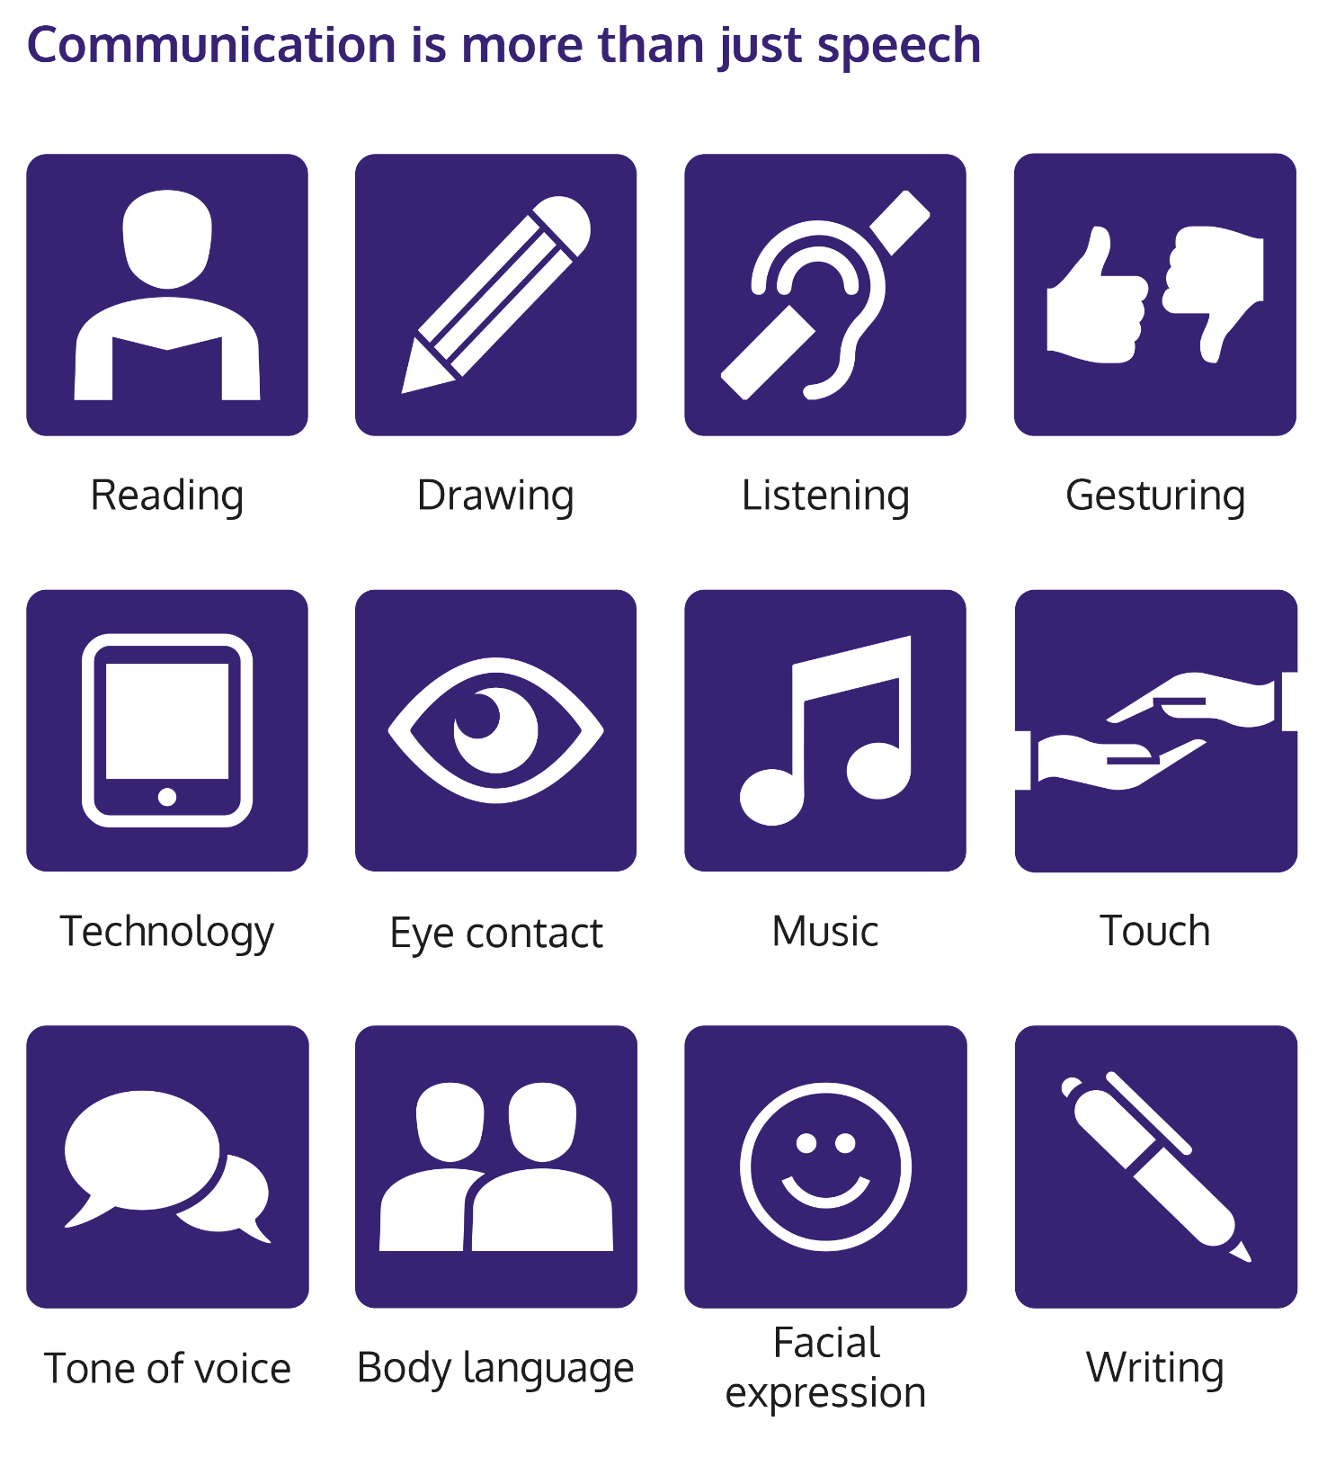

Using technology
Modern technology offers a whole range of options to help you communicate. Computers, mobile devices and smart speakers can all be used in different ways to access things you need and help with conversations.

Touch screen devices like phones and tablets usually have built-in accessibility software, as well as standard apps such as the camera and audio recording.
Examples of ways to use a mobile phone or tablet
- Set the device to speak the text on screen.
- Set the device to be voice-controlled, and carry out instructions such as web searches or sending messages.
- Use a device to pre-record spoken messages to use in different situations.
- Take photos of objects to show people things you need, or to help explain things.
- The calendar app can help with setting a routine, and send reminders for appointments.
- List and reminder apps can help to remember words and tasks. These can also be used using voice control if someone has trouble with typing.
- Some video calling apps let you add instant subtitles which can help with comprehension.

There are apps and programmes specifically for communication problems. The Aphasia Software Finder has information about what’s available at aphasiasoftwarefinder.org. You can also find details of list aphasia therapy apps on our free online tool mystrokeguide.com.

Involving family and carers
Speech and language therapy also involves the people around someone, including family, friends and carers. The therapist helps them learn how to have a successful conversation with the person who’s had a stroke. They can help by using strategies for supporting communication, and by being encouraging. They can also help the person by engaging in positive conversations, which can develop their confidence.

Improving confidence
Speech and language therapy helps to build confidence, so someone feels able to join in conversations, talk to new people and do the things they want to do. Meeting other stroke survivors with communication problems can also help.
Speech and language therapy isn’t just about the time spent with the therapist. Getting better and becoming more confident only comes with practice. So the more they practise outside of sessions, the more progress they will see.

How long does therapy last?
There is no set length of time for speech and language therapy. Ideally, it will continue until someone has achieved their goals. However, people sometimes find that their speech and language therapy ends before they feel ready.

Knowing that they are no longer going to have regular advice and support from a speech and language therapist can cause some anxiety. However, recovery doesn’t end with therapy. As the person continues to practise their skills, they will probably continue to improve their skills and confidence.

Keeping going with communication
The speech and language therapist can give suggestions for communication in everyday life. They can give exercises, tips for conversations, and apps or books.

“You have to teach yourself again... you have to teach yourself to talk to people.” John

What happens after speech and language therapy?
The speech and language therapist will explain the kinds of communication support available locally, and can refer someone to services. They also explain what to do if someone needs more therapy in future.

Volunteering can be a good way to practise communication. Someone can practise with their family at home, and there are also workbooks and apps for recording communication goals.
Speech and language therapists can provide information about life after stroke. This information should be provided at a level that the person can read, and often therapists will adapt the information to make it easier to understand.

“Physically and mentally and verbally, you need to just practise and practise and practise.” John

What about private therapy?
Using a private speech and language therapist (SLT) may be an option if someone has private health insurance, or the ability to pay for sessions themselves.

They should look for someone who has experience of working with people who have had a stroke. To find a private SLT, you can check the Association of Speech and Language Therapists in Independent Practice at helpwithtalking.com. All practising SLTs must be registered with the Health and Care Professions Council (HCPC). Check that the SLT you have chosen is registered on the HCPC website at hpc-uk.org/check.

How does therapy help recovery?

Neuroplasticity: re-wiring the brain

Your brain is amazing! It has the ability to re-wire itself, allowing you to improve skills such as walking, talking and using your affected arm. This process is known as neuroplasticity. It begins after a stroke, and it can continue for years.

How does it happen?
Brain cells send messages around the brain. A stroke damages some of the connections inside the brain, and between the brain and the body.

When you do rehabilitation activities, it encourages the brain to start making new connections in the healthy parts of the brain. Building up those connections makes your brain better at controlling your body, and lets you do more things you want to do.
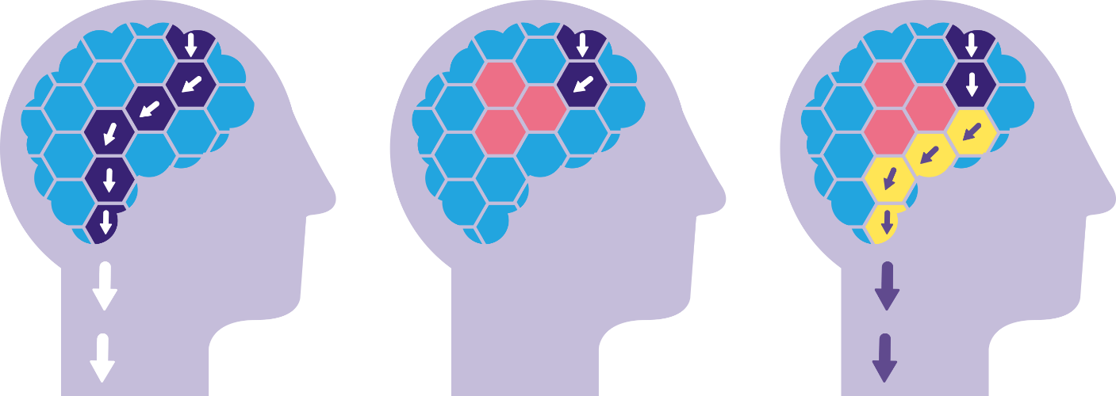

You can help this process by practising rehabilitation activities. There is no time limit on neuroplasticity, and it doesn’t only happen during therapy. Every time you take an extra step, say a new word, or do a hand exercise, it helps the brain make new connections.

Are there aids or equipment that can help?

A speech and language therapist will recommend equipment and apps for supporting communication. Some examples include:

- Carrying a pen and notebook so they and the person they are speaking to can use drawing and writing to communicate.
- Using a mobile phone or tablet (see page x for some ideas).

- Communication cards
A communication card is a card that someone can show to explain that they have problems with speaking. It’s usually small, and fits in a wallet or purse.
Order a communication card from our website stroke.org.uk/shop.

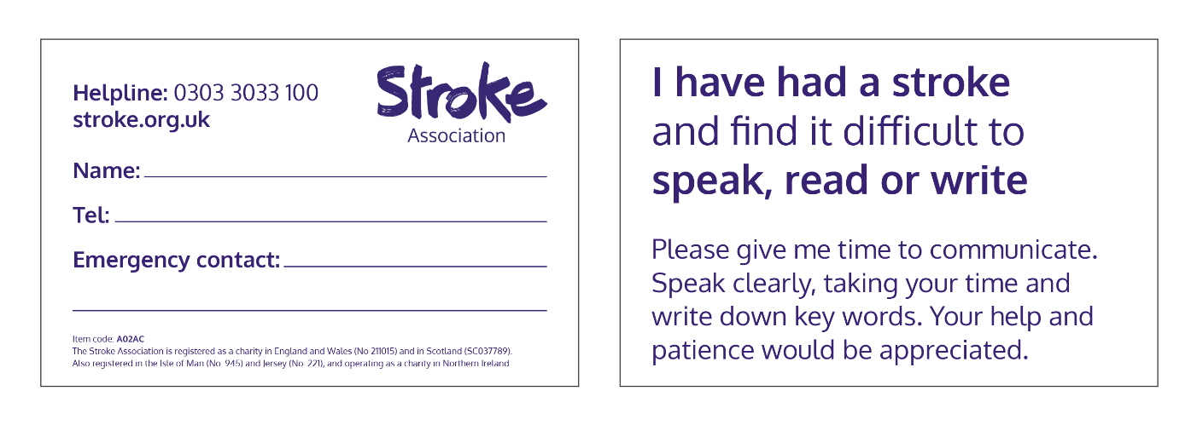

- Communication passport
A communication passport is a document that gives important information about the person with aphasia. Everything from the kind of communication problems they have and the medication they take, to likes and dislikes, and where they come from. This can be especially helpful if someone often meets new people, and it can also be helpful if someone has a number of carers. Anyone can make their own communication passport, although there are many templates available to help you.

- Charts and books
Simple communication aids include alphabet boards, communication charts and books. They display large letters or words, as well as sets of pictures, photos or symbols to point to. Some people find symbol sets useful. These are set of pictures that you can use to put messages together. There are many sets available, covering a range of different topics.

- Electronic aids
Voice output communication aids (VOCAs) are devices that can help if someone has problems speaking clearly. They use a computer-generated voice to play a message aloud. Some work by pressing a button to play a pre-recorded message, like “How are you?”, and others have a keyboard to create a message for the VOCA to read aloud.

- Apps and computer programmes
Apps are computer programmes that can be downloaded from the internet and used on a computer or mobile device.
Many apps are free or free to try out, but others can cost over £50 or have a monthly subscription fee. Often apps have a free trial version which you can upgrade to the full paid version.

There are apps and computer programmes for practising speech and language exercises.
This kind of computer-based therapy works best with some guidance from a speech and language therapist.

Mobile devices and computers have many useful features as standard.

Accessible guide to getting online for people with aphasia
Our free guide to support people with aphasia to get online is online at stroke.org.uk/getting-online. You can also call our Helpline for a print copy.

AbilityNet
AbilityNet is a charity which helps disabled people to use technology. They can provide volunteers to help people to get started with technology. Call the helpline 0800 048 7642 or visit abilitynet.org.uk.

Tips to share with someone with aphasia

Practise, practise, practise…
The more you practise your communication, the more progress you’ll make. So take every opportunity you can – read things out loud, repeat the names of songs on the radio, list the days of the week in the shower, whatever you can think of. If you have dysarthria, keep doing the exercises given by the speech and language therapist.

Perhaps the best thing you can do is to have conversations with friends and family. Let them know what they can do to help the conversation go well. Perhaps it helps if they speak about one thing at a time, or give you more time to make your point.

… but take breaks
Communication can become exhausting, especially to begin with. So it’s important that you don’t push yourself too hard. Listen to your body. If you’re getting tired, take a rest.
Find things you enjoy doing with others which don’t need you to talk so much, such as watching a sport or doing gardening. You might find that you have more energy at certain times of the day.

Be kind to yourself
It’s easy to feel stupid when you’re always getting words wrong. And the constant struggle to get across what you want to say can be both frustrating and exhausting. It’s a lot to cope with, and you can be kind to yourself by reminding yourself how hard you are working and how much you have achieved. If you’re having a frustrating moment in a conversation, remember you can take a break or try again another time. Some people say that laughing about it can help.

Be up front with people
People are more likely to give you the help and time you need if they know you’ve had a stroke and struggle with speaking because of it. Using a communication card may help. It’s not always easy to explain, but you’ll usually find people are much more understanding than you think they will be.

Get support
Emotional changes are very common after a stroke. So if you’re finding things difficult, talk to your speech and language therapist or speak to a family member or friend. Read more about emotional changes after stroke online stroke.org.uk/emotional-changes. You can contact our Helpline by phone or email for someone to talk to. If you are feeling very anxious, or have feelings of sadness or low mood for a long time, contact your GP.

Embrace technology
Smart phones and tablets can be useful for people with communication problems and the people they are communicating with. Try asking your speech and language therapist for some tips, or contact AbilityNet.

Tips for family and friends
It can be difficult to know how to help someone when they’re finding communication difficult. So here are some tips to help you.

Get involved
If your family member or friend isn’t able to communicate in the same ways as before, then you’re going to need to learn new ways to do it too. Ask them what helps. Go along to their speech and language therapy sessions if you’re able to, or ask their speech and language therapist to send you information. Turn to our guide to good conversations later in this guide.

Work together
Many people with communication problems say they feel invisible and that people aren’t interested in what they have to say. So make sure your family member or friend is included in your conversations – whether it’s an argument, an important decision that needs to be made, or simply a chat about what’s happening that week.
If they meet someone new, make sure they are introduced and included in the conversation.

Be patient
All relationships rely on communication so it can be very hard when it suddenly becomes difficult. Communication problems can affect relationships between partners and spouses, but help is available. Read more about changes to intimate relationships at stroke.org.uk/relationships or call the Helpline for print copies.

Support their independence
You might need to support someone to start with, by doing things like answering the phone or going to appointments with them. But as their communication begins to improve, encourage them to start doing more things on their own if they can. Ask them what they’d find helpful.

Make time
People can feel very lonely and isolated when they’re not able to talk or go out in the same way they used to. So simply spending some time with someone can really help. Make an effort to talk to them about how they are coping. Find something you can do together that doesn’t require as much chat, like cooking a meal or playing a familiar game.

A guide to good conversations
When you’re talking to someone, it’s up to both of you to make sure the conversation is a good one. This doesn’t change if one of you has communication problems. It may make your conversation a bit more difficult, but it can still be enjoyable and help you to feel close.

These are our tips to help you.

Before you start

- Reduce distractions and background noise
Remove distractions like mobile phones, and make sure you’re not under any other pressures, so you can give each other your full attention.
- Choose a good moment
Ask them to pick a time when they have enough energy and concentration to talk. Stroke can cause fatigue, which can be worse in the afternoon.
  - Focus on what you’re doing
Look as if you’re ready to talk, sit close to or opposite each other and make eye contact. It is easier to have a one-to-one conversation rather than a group. If you are meeting as a group you might need a ‘chairperson’ who can manage the conversation and make sure one person is speaking at a time.
- Don’t worry
Conversations are about sharing and understanding each other, so it doesn’t matter how you do it or how long it takes. Be ready to make mistakes, you just have to keep trying.
- Get ready to listen
The best conversations involve everybody equally, so good communication is as much about listening as it is talking.
- Have resources ready
Have a pen and paper handy, and anything else you think that can support communication. For example, diary, photos, calendar, magazines or books you want to talk about.

To be a good listener you need to:
- Give time and attention.
- Try not to interrupt.
- Allow silences.
- Ask questions.
- Give feedback.
- Check you’ve understood.

During your conversation

Do
  - Remember that conversation is more difficult if you are somewhere noisy or full of distractions.
  - Ask how they want you to give support.
  - Keep it simple. Keep sentences short and ask one question at a time.
  - Give time to respond. Waiting for a while after you say something can help.
  - Say when you don’t understand. It’s not a problem, you just need to try it again. It can help to repeat back the part of the message you have understood.
  - Stick to one topic at a time and make sure you both know when you’ve moved on to a new one. If the conversation breaks down, it can be helpful to check you’re talking about the same topic. You can try writing down key words.
  - Use whatever you can: point to things, make gestures, write, draw, hum or sing. Ask them what they find helpful.
  - Talk naturally about things that are of interest to you both.
  - When things are going wrong, humour can help break the tension.
  - Use either/or questions rather than open questions as this can be more challenging. Don’t only use open questions in a conversation.

Don’t
- Rush. Give each other time to understand and respond.
- Finish sentences or guess what the other person is trying to say.
- Ask questions you already know the answers to. It’s a conversation, not a test.
- Correct what they’ve said, especially if you’ve understood it.
- Pretend to understand what they’ve told you or assume that you have: always check.Forget that you’re talking to an adult who has problems with their communication, not their intelligence.

Some other things to be aware of

- Check yes/no responses. Sometimes people with aphasia say yes or no when it’s not what they mean. So check with a simple thumbs up or thumbs down, or draw a tick and a cross on a piece of paper and ask them to point.

- Write down key words as you talk, so you can refer to them if you need to Even if they can’t read very well, many people can still recognise single words.

- If your conversation partner is struggling to think of a word, then ask them to spell it, write it down, draw it point to what it begins with on an alphabet chart, point. You can also encourage them to ’talk around it’ by describing it

- Think about other things that you can use to help your conversation. Do you have holiday pictures from your holiday you’re talking about? Or why not sit down with a photo album or a newspaper, or perhaps a website about something you’re both interested in, and talk about that together?

- Ask them what they find helpful. Also let them know what helps you in the conversation.

- There is a difference between casual conversation and formal conversations. After formal conversations, like a work meeting it can be helpful to write down and share key points. In a medical appointment it might help to write down key points and anything agreed.

Five rules of good conversations
- Show respect.
- Give each other time.
- Listen.
- Show you are concerned and care about them.
- Never assume.

Free online training for better conversations
Aphasia experts at University College London have produced a free e-learning resource aimed at family and friends, people with aphasia, and professionals supporting them. You can find a link to the Better Conversations resource at extendstore.ucl.ac.uk.

Where to get help and information

From the Stroke Association

Helpline
Our Helpline offers information and support for anyone affected by stroke, including family, friends and carers.
Call us on 0303 3033 100, from a textphone 18001 0303 3033 100.
Email helpline@stroke.org.uk.

Read our information
Get more information about stroke online at stroke.org.uk, or call the Helpline to ask for printed copies of our guides.

My Stroke Guide
The Stroke Association’s online tool My Stroke Guide gives you free access to trusted advice, information and support 24/7. My Stroke Guide connects you to our online community, to find out how others manage their recovery.
Log on to mystrokeguide.com today.

Other sources of help and information

Aphasia Alliance
Website: aphasiaalliance.org
Lists all the main organisations dedicated to supporting people with aphasia and their carers.

Brain and Spine Foundation
Website: brainandspine.org.uk
Helpline: 0808 808 1000
Comprehensive information about conditions affecting the brain and spine, plus a helpline and support groups.

The Brain Tumour Charity
Website: thebraintumourcharity.org
Tel: 0808 800 0004
Information about living with a brain tumour, and language difficulties due to brain tumours.

Chest Heart & Stroke Scotland
Website: chss.org.uk
Advice Line: 0808 801 0899
Email: adviceline@chss.org.uk
Communication support in Scotland, including groups and one-to-one support. They also have information on their website that has been written for people with communication problems.

Communication Matters
Website: communicationmatters.org.uk
Tel: 0113 343 1533
Practical advice and tools for people living with complex communication needs.

Dementia UK
Website: dementiauk.org
Tel: 0800 888 6678

Headway
Website: headway.org.uk
Tel: 0808 800 2244
Information and support for traumatic brain injury, including communication and cognitive problems.

The Tavistock Trust for Aphasia
Website: aphasiatavistocktrust.org
Tel: 0152 529 0002
Information about aphasia and the ‘Aphasia Software Finder’. Small grants of up to £1000 for individuals and groups, and funding for research and projects.

About our information
We want to provide the best information for people affected by stroke. That’s why we ask stroke survivors and their families, as well as medical experts, to help us put our publications together.

How did we do?
To tell us what you think of this guide, or to request a list of the sources we used to create it, email us at feedback@stroke.org.uk.

Accessible formats
Visit our website if you need this information in audio, large print or braille.
Always get individual advice
This guide contains general information about stroke. But if you have a problem, you should get individual advice from a professional such as a GP or pharmacist. Our Helpline can also help you find support. We work very hard to give you the latest facts, but some things change. We don’t control the information provided by other organisations or websites.

© Stroke Association 2021
Version 5. Published: Aug 2021
To be reviewed: April 2023
Item code: F03

Every five minutes, stroke destroys lives. We need your support to help rebuild them. Donate or find out more at stroke.org.uk.

The Stroke Association is registered as a charity in England and Wales (No 211015) and in Scotland (SC037789).
Also registered in the Isle of Man (No. 945) and Jersey (No. 221), and operating as a charity in Northern Ireland.

