A complete guide to communication problems after stroke
Problems with communication are common after stroke. This guide will help you understand more about them.

It explains why you may not be able to communicate properly after your stroke and how speech and language therapy can help. It also tells you what can do about communication problems and has tips to help other people support you.

It’s aimed at people who have had a stroke but there is information for family and friends as well.

We have information on all aspects of stroke. If you have a question that is not answered in this guide visit stroke.org.uk or call our Stroke Helpline on 0303 3033 100.

What’s in this guide?

Why can’t I communicate properly? 3
What kinds of problems can this cause? 5
Aphasia 5
Problems with reading and writing 6
Dysarthria 7
Apraxia of speech 8
Will it get better? 9
Are there treatments that can help? 10
Speech and language therapy 10
Are there aids or equipment that can help? 17
Communication cards and passports 17
Charts and books 19
Electronic aids 21
Apps and computer programmes 21
What can I do about my speaking problems? 23
Where can I get help and support? 25
How we can help 25
Other organisations that can help 26
Tips for family and friends 28
A guide to good conversations 30

Why can’t I communicate properly?

Communication problems happen because a stroke damages your brain.

When we communicate our brain has to complete a series of tasks. So when you’re talking to someone and they ask you a question, for example, your brain has to understand what you are being asked, decide on your answer and put the words together, before you can give them a reply.

Different parts of your brain are responsible for each of these tasks. Depending on the area of your brain that is damaged, you could have problems with any part of this process. Communication isn’t just about speaking, however. Many people also have problems with reading and writing.

Communication problems do not affect your intelligence
If you have communication problems you simply have problems with the process of speaking and sometimes understanding language. It has nothing to do with intelligence at all.

What happens when we’re asked a question

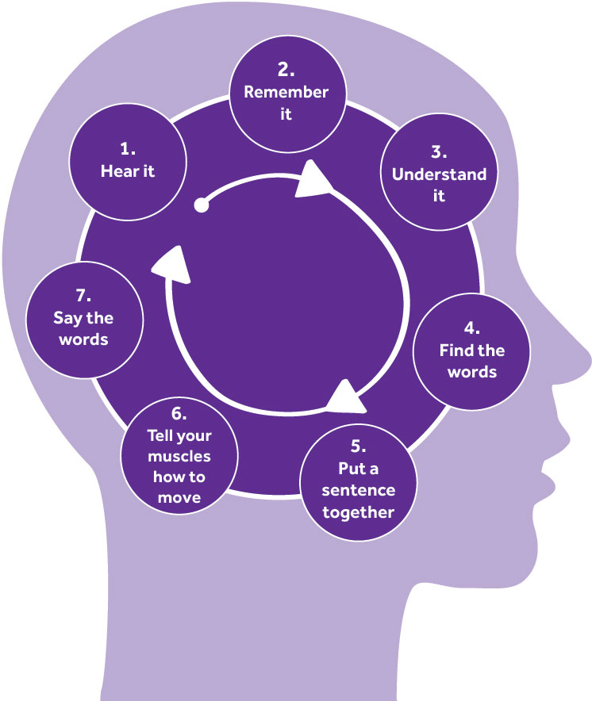

What kinds of problems can this cause?

Aphasia
Aphasia affects your ability to speak and understand what others say. It can also affect your ability to read and write. Aphasia is sometimes called dysphasia.

It happens when you’re no longer able to understand or use language. It does not affect your intelligence, although some people may treat you as if it has. Aphasia is a common problem after stroke and around a third of stroke survivors have it.

There are different types of aphasia:
- Broca’s aphasia or expressive aphasia, is when you find it very difficult to speak. You may only be able to say single words or very short sentences, although it’s usually possible for other people to understand what you mean.
- Wernicke’s aphasia or fluent aphasia, is when you’re able to speak well and use long sentences, but what you say does not make sense. You may not know that what you’re saying is wrong, so you may get frustrated when people don’t understand you.
- Global aphasia is when you have serious communication problems and you may not be able to speak, read or write at all.

Signs of aphasia
While it will be different for everyone, these are some of the more common signs of aphasia:
- not being able to understand much of what other people say
- not being able to form words, only sounds
- only being able to say single words or very short sentences, like “want drink”
- speaking slowly, with very long pauses
- missing out words or getting them in the wrong order
- getting stuck on a single word or sound, and repeating it over and over
- saying one word when you mean another, so you may say “milk” instead of “water”, or “yes” instead of “no”
- not being able to find the right word, even though you can describe what you’re thinking of
- talking nonsense, but not realising that you’re not making any sense
- being able to read headlines in a newspaper, but not the rest of the text • being able to write, but not read what you’ve written.

“Losing your communication doesn’t just affect you, it affects everyone around you too.” Chris

Problems with reading and writing

Alexia is when you find reading difficult, because you’re not able to recognise written words. It is sometimes called word blindness or visual aphasia.

If you have problems with writing this is known as agraphia. You may find it difficult to spell words, write sentences in the right order or draw a letter, or you may not be able to write at all.

Dysarthria
To speak clearly, we need to control the muscles in our face, mouth and throat as well as our breathing. Dysarthria happens when you’re not able to do this.

Dysarthria doesn’t affect your ability to understand other people or to find words and put them together, unless you have other communication problems at the same time.

Dysarthria is a common problem after stroke. Out of everyone who has a stroke, nearly half experience it in some way.

Signs of dysarthria
Dysarthria affects people in different ways. For some, their speech may only be a little unclear and people will usually be able to understand them. However, for others it means that they can’t speak clearly at all. Some common signs include:
- not being able to speak clearly
- slurred or slow speech
- speaking with a quiet or strained voice, or one that doesn’t change its tone
- hesitating a lot or speaking in short bursts, rather than full sentences.

Apraxia of speech
Apraxia is when you have problems moving your muscles in the right order. This makes is hard to move your body in the way you want to. Some people call this dyspraxia.

Apraxia of speech is when you can’t move the muscles in your face, mouth or throat in the order you need to when you’re speaking. This can make it difficult for other people to understand you. You may not have any weakness in these muscles and you may be able to control them individually without any problem. However, you can’t move them in the way you want to when you try to speak.

This is because apraxia is a problem with planning movements, rather than the movements themselves. So even though you may not be able to say goodbye if someone asks you to, you may be able to say it when you go to leave, because you’re doing it without thinking.

Signs of apraxia of speech
It can be hard sometimes to tell the difference between apraxia of speech and other communication problems. These are some common signs:
- not being able to say words clearly, especially when someone asks you to
- your speech changes and words sound different every time you say them
- you try to correct yourself, because you know things sound wrong
- you hesitate between words or need several attempts before you can say a word
- you are able to say things clearly when you recite them in a list (like days of the week or numbers), but not when you’re asked to say them on their own
- not being able to speak at all sometimes.

Will it get better?

Most communication problems do improve. However, how much they’ll improve or how long it will take is very difficult to predict, as it’s different for everyone.

Problems tend to improve quite quickly within the first three to six months, but you can continue to recover for months and even years after this. Whilst some improvement will happen naturally, you are likely to make a much better recovery if you have speech and language therapy, practise your exercises and try to communicate as much as you can.

For most people, getting better is about returning to the way they were before their stroke. However, this isn’t always possible. Even if you get close, you may still have problems from time to time, especially when you’re tired or stressed.

But even if you don’t recover completely, there are many ways to communicate that don’t rely on speaking. So it doesn’t have to stop you from doing what you want to do. Lots of stroke survivors continue to live full and happy lives, even though they still have problems with communication.

“I had a stroke eight years ago. I still get frustrated with myself when I can’t get my words out and embarrassed when I say the wrong word. But I get annoyed at other people when they think I’m ok. Not all disabilities are visible.” Clair

Are there treatments that can help?

Speech and language therapy
Speech and language therapy helps you to improve your ability to communicate. Research shows that people who have speech and language therapy improve much more than people who don’t.

Many people think that speech and language therapy is about ‘fixing’ your problems so that you can speak as well as you did before. However, it’s not always possible to recover your speech completely.

So it’s important to find things that will help you communicate despite your problems with speaking. These are known as compensation or coping strategies. They include anything from gestures and body language to alphabet charts and electronic devices – anything that helps you to get across what you want to say.

So whilst your speech and language therapy will be about getting you to speak and understand more, it will also focus on learning other ways to communicate.
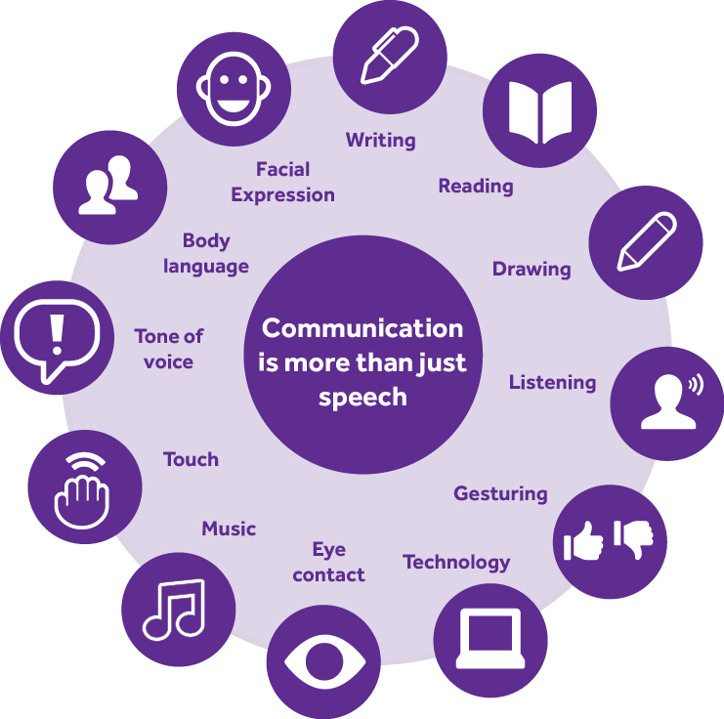

Confidence also plays an important part in your ability to communicate. Speech and language therapy helps to build your confidence, so you feel able to join in conversations, talk to new people and do the things you want to do.

There is evidence that certain drugs may help to treat some speaking problems. However, it’s not known whether they work better than speech and language therapy or whether they are completely safe. More research needs to be done before they can be widely recommended.

What does speech and language therapy involve?
There’s no set pattern for speech and language therapy. You will have regular sessions with a speech and language therapist, but what you do in these sessions will depend on the problems that you have and what’s important for you to work on.

Many people start speech and language therapy thinking that they just need to turn up and do what their speech and language therapist tells them to. But speech and language therapy is about working towards goals and these goals need to be set by you, together with your speech and language therapist. It’s no good working on your spelling, if what you really want to do is tell your family that you love them.

Speech and language therapy isn’t just about the time you spend with your speech and language therapist. Getting better and becoming more confident only comes with practice. So the more you do outside of your sessions, the more progress you’ll see within them.

Speech and language therapy should also involve your friends and family. If you’re learning new ways to communicate, then the people around you need to learn as well. So encourage your friends, family and carers to attend your speech and language therapy sessions with you if they can, and practise with you at home.

How do I get speech and language therapy?
When you’re in hospital you’ll be referred to a speech and language therapist for an assessment to understand the kinds of problems you’re having. Most stroke teams include a speech and language therapist, but they can be based in other hospital departments and in the community as well.

SALT is short for speech and language therapist. This is someone who works with people to improve their ability to communicate. They also work with people who have swallowing problems.

Depending on what you find out from your assessment, the speech and language therapist will discuss the kind of therapy that will be best for you and set up regular sessions. This may start in hospital or when you return home.

If services are busy, you may have to wait several weeks for your speech and language therapy to start once you return home. Many people find this difficult, so try to find out as much as you can whilst you’re in hospital. Ask your speech and language therapist when your therapy will start and what you can work on while you wait.

If you don’t stay in hospital, or you don’t notice difficulties until you’ve returned home, then speak to your GP.

How long does it last?
There is no set length of time for speech and language therapy. Ideally, it will continue until you’ve achieved your goals. However, this isn’t always the case. Many people find that their speech and language therapy ends before they feel ready.

Knowing that you’re no longer going to have regular advice and support from your speech and language therapist can knock your confidence and make you worry that you won’t improve any more than you have.

But recovery doesn’t end with therapy. As you carry on practising your new skills, you’ll probably see that things will get even better and your confidence will continue to improve.

Are there exercises I can practise on my own?
There aren’t exercises that we can recommend to everyone, because what works for one person, won’t be suitable for someone else. Exercises need to be tailored to you, the problems you have and what you want to achieve. So ask your speech and language therapist about exercises you can continue to practise on your own. There may also be computer programmes or workbooks that they can recommend.

“You have to teach yourself again... you have to teach yourself to talk to people.” John

What happens after speech and language therapy?
In many areas there are organisations who offer communication support such as:
- one-to-one sessions with someone who is trained to provide communication support
- communication or conversation groups where you can practise with other people
- partner schemes that will put you in touch with someone else who has communication problems so that you can practise together.

Before your therapy ends, your speech and language therapist should talk to you about the kinds of communication support that’s available to you and put you in touch with services that could help. They should also explain how you can contact them or another speech and language therapist if you need to in the future.

Depending on how confident you feel, there may be other ways to improve your communication. Many people volunteer, for example, either at their local stroke group or for another charity or organisation. This can help you become more confident about talking to new people and in different situations.

If there are still things that you want to work on, there are workbooks you can buy or websites and apps you can use to set yourself goals. These can help you break your goals down into smaller steps and record your progress as you work towards them. Ask your speech and language therapist if they can recommend some.

Why haven’t I been offered speech and language therapy?
You won’t be offered speech and language therapy if your speech and language therapist thinks that you won’t get any benefit from it. This may be because you’re too ill to take part in therapy sessions or if your problems seem to be getting better on their own.

It’s important that you and your speech and language therapist review this further down the line, as there may come a time when you would benefit from it.

“Physically and mentally and verbally, you need to just practise and practise and practise.” John

What about private therapy?
If you’re not offered therapy through the NHS, or if you feel that you didn’t get enough, you may want to think about private therapy.

Private therapy means finding your own speech and language therapist and paying for treatment yourself. Prices can range between £50 and £90 for one session and initial assessments are likely to be more. So this isn’t an option for everyone. If you do decide to pay for private therapy, we suggest finding a speech and language therapist who has experience of working with people who have had a stroke. Contact our Stroke Helpline if you’d like to know more about private treatment.

Are there aids or equipment that can help?

There are aids that can help make communication quicker and easier. They range from simple charts with words and pictures to portable electronic devices.

Because there are so many communication aids available, it’s best to get advice from your speech and language therapist about which ones would be most helpful for you. Here’s a brief overview of the kinds of aids that are available.

Communication cards and passports
A communication card is a card that you can use to explain to people that you have problems with speaking. It’s usually small, so that you can carry it with you in your wallet or purse. A communication card can help you explain to people (like shop assistants and waiters, for example) that you need a little more time or help. We have communication cards that you can order from our website. Go to shop.stroke.org.uk

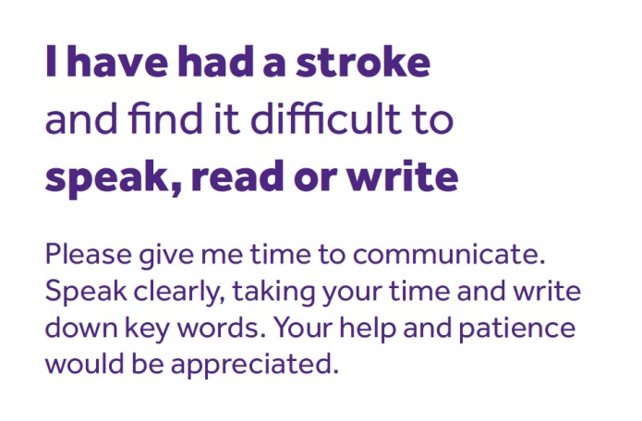

A communication passport is a document that tells people important information about yourself – everything from the kind of communication problems you have and the medication you’re taking, to your likes and dislikes and where you grew up. If you have problems speaking, you can use this to tell other people everything they need to know about you. This can be especially helpful if you have a lot of different visitors or carers. Anyone can make their own communication passport, although there are many templates available to help you.

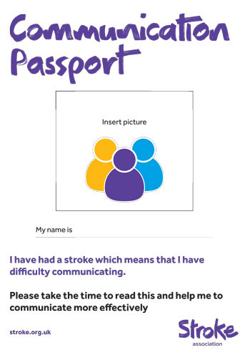

Charts and books
Simple communication aids include alphabet boards, communication charts and books. They display large letters or words, as well as sets of pictures, photos or symbols that you can point to. For example, many have pictures to represent feeling hungry or thirsty or being in pain.

These communication charts can be useful, especially in hospital, when your communication problems are likely to be worse. However, they may not be as suitable for the kind of conversations you want to have when you’re back at home.

Our communication chart has been designed for people who have had a stroke. It costs £2.50 and you can order it from our website. Go to shop.stroke.org.uk

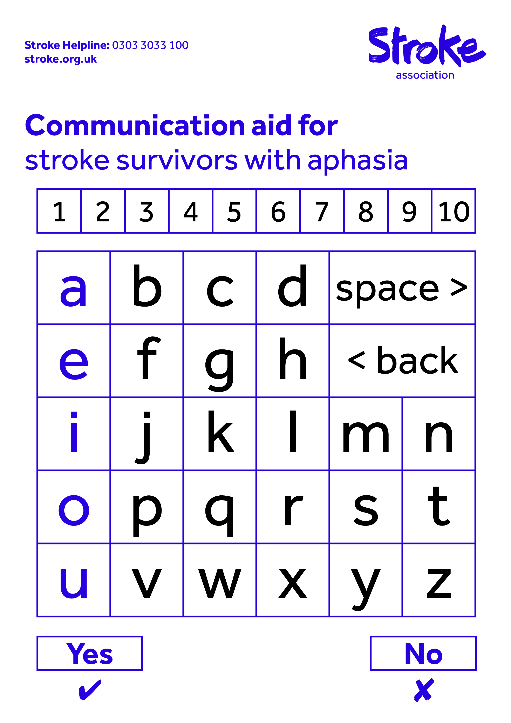

An e-tran frame is a special chart for people who are not able to move their hands to point. Instead, you can use your eyes to indicate a letter, word or symbol that is attached to a large frame, which is held in front of you by a trained carer.

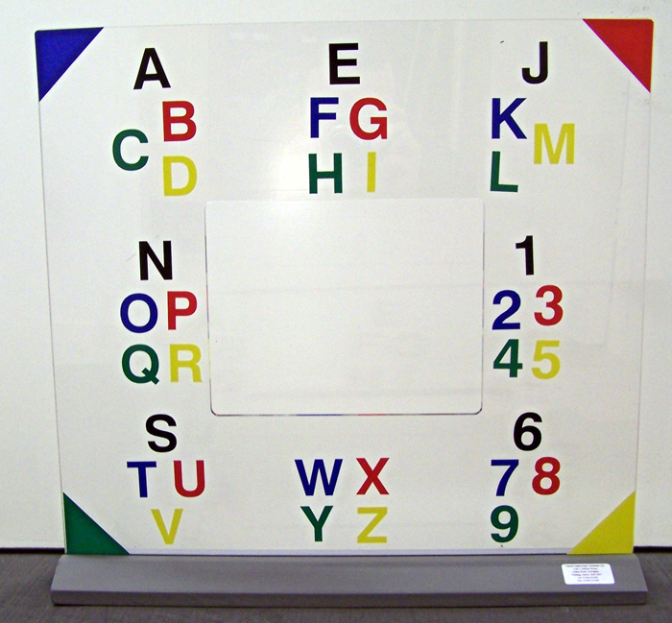

Symbol sets are sets of picture symbols that you can use to put messages together. There are many sets available, covering a range of different topics. You can also get them in different formats, depending on what is easier for you to use.

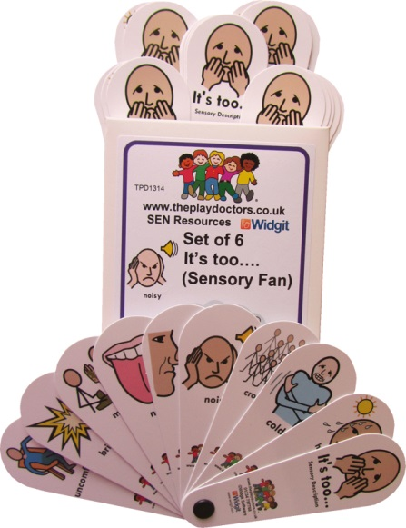

Electronic aids
Voice output communication aids (VOCAs) are devices that can help you if you have problems speaking clearly. They use a computer-generated voice to play a message aloud. Some work by pressing a button to play a pre-recorded message, like “How are you?”, whereas others have a keyboard so you can type your own message for the VOCA to read aloud.

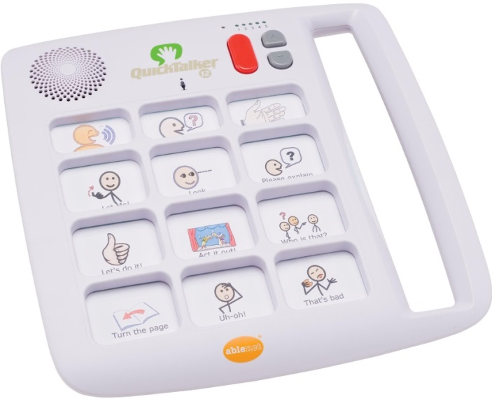

Apps and computer programmes
Apps are computer programmes that can be downloaded from the internet and used on your smartphone or tablet computer (such as an iPad).

There are over a hundred apps that have been designed to help people with communication problems, but there are also many others that you may find helpful – such as apps that can set picture reminders on your phone, rather than written ones, or apps you can use to add voice recordings to the photos that you take.

Many apps are free or free to try out, whereas others can cost over £50. They are not always available for all devices, so it’s important to do some research to find what’s best for you.

The Aphasia Software Finder has information about software and apps for people with communication problems. It provides information about what the apps do, how much they cost and what devices they can be used on. The website is funded by a charity, The Tavistock Trust for Aphasia, and run by independent researchers, so all the information is impartial. Go to www.aphasiasoftwarefinder.org

There are also computer programmes that you can use to continue practising your speech and language exercises. There are lots of different programmes that can be tailored to the things that you need to work on, whether it’s speaking, writing or using numbers.

This kind of computer-based therapy works best when you have a speech and language therapist to guide you. They can make sure that you do the exercises correctly and that they’re not too easy or too difficult. You may use computer programmes during the sessions you have with your speech and language therapist or they may teach you to use a computer to practise at home.

You can also buy speech and language therapy programmes yourself. There are a number of companies that sell them. However, it’s a good idea to get advice from your speech and language therapist first. These programmes can be expensive, so you need to make sure that you get something suitable. Most companies will offer you a free trial of their programme before you buy it, or your speech and language therapist may be able to show you an example.

What can I do about my speaking problems?

Practise, practise, practise…
The more you practise your communication, the more progress you’ll make. So take every opportunity you can – read things out loud, repeat the names of songs on the radio, list the days of the week in the shower, whatever you can think of. And ask your friends and family to help you. Communication is also about confidence, which will come with practice too.

… but know when to stop
Communication can become exhausting, especially to begin with. So it’s important that you don’t push yourself too hard. Listen to your body. If you’re getting tired, take a rest. Find things to do that don’t need you to talk, so that you can give yourself a break. Try listening to music, watching sport or gardening, or playing a game, for example.

Laugh as much as you can
It’s easy to feel stupid when you’re always getting words wrong. And the constant struggle to get across what you want to say can be both frustrating and exhausting. It’s a lot to cope with, but for many people laughing is the best way to do it. Not only is it a good way to release tension, but it can help the person you’re talking with to feel more relaxed and happy as well.

Be up front with people
People are more likely to give you the help and time you need if they know you’ve had a stroke and struggle with speaking because of it. So explain to new people. Using a communication card may help. It’s not always easy to do, but you’ll usually find people are much more understanding than you think they will be.

Get it out
Coming to terms with the effects of your stroke is difficult enough, but it can be even harder when you’re not able to talk about it very well. But this shouldn’t stop you from getting the emotional support you need. So if you’re finding things difficult, talk to your speech and language therapist or speak to a friend or family member. You may have to arrange it so that you have the time and space you need to talk things through, but it will be worth the effort if you do. Hobbies like art, music, photography or poetry can give you a way of expressing your feelings as well.

Embrace technology
Even if you’re not used to technology, smart phones and tablet computers are actually pretty easy to use and many people with communication problems find them helpful. You can use them to video chat with people, for example, which is often easier than speaking on the phone. Or you can use them to take pictures of things that you want to ask for, like your favourite foods or members of your family. Of course, they can be expensive to buy but many people find them worth the investment.

Where can I get help and support?

If you’re worried about communication problems, then speak to your doctor or speech and language therapist.

How we can help
Our Stroke Helpline can give you information and support on any issue you or your family may be facing after stroke. Whatever the problem, we’re here to help.

We have coordinators in some areas of the UK, who can meet with you and your family and give you information, practical advice and emotional support. We also run stroke groups across the UK.

We have communication support coordinators in a lot of areas. They run groups where you can practise your communication with other stroke survivors or someone can work with you one-to-one.Even if we don’t have these services in your area, we can tell you about others that do.

Or you can talk to other people affected by stroke on our online forum TalkStroke or on our Facebook page. Visit stroke.org.uk/talkstroke or facebook.com/TheStrokeAssociation

To find out how we can help, just get in touch:
- call our Stroke Helpline on 0303 3033 100
- email info@stroke.org.uk
- visit stroke.org.uk
- write to us at Stroke Information Service, Life After Stroke Centre, Church Lane, Bromsgrove, Worcestershire B61 8RA.

Other organisations that can help
Below are some other organisations in the UK that may be able to help. Contact our Stroke Helpline if you’d like to know about others in your area.

Connect is a charity for people with aphasia. They run a befriending scheme where you can get one-to-one support from a volunteer with aphasia. They also offer face-to-face counselling at their office in London, or via video chat for people who live elsewhere. You can download a free Aphasia Information Pack from the website, which includes a film about living with aphasia.

Website: www.ukconnect.org
Tel: 020 7367 0840
Email: info@ukconnect.org

Speakability is a charity that supports people with aphasia. They have information that is written for people with communication problems on their website. They also run a network of self-help groups for people with aphasia across England, Scotland and Wales.
Website: www.speakability.org.uk
Tel: 080 8808 9572 (Tue–Thu, 11am–3pm)
Email: speakability@speakability.org.uk

Communication Matters has information about methods of communication you can use instead of writing or speaking (known as augmentative and alternative communication or AAC for short).

Their website lists all the communication aid centres and AAC assessment services across the UK. These services can tell you about aids that can help you communicate and show you how to use them. Some also lend out equipment.

Website: www.communicationmatters.org.uk
Tel: 0845 456 8211
Email: admin@communicationmatters.org.uk

Chest Heart and Stroke Scotland is a charity for people affected by chest and heart conditions as well as stroke. They offer communication support in Scotland, including groups and one-to-one support. They also have information on their website that has been written for people with communication problems.

Website: www.chss.org.uk
Advice Line: 0808 801 0899
Email: adviceline@chss.org.uk

Tips for family and friends
It can be difficult to know how to help someone when they’re finding communication difficult. So here are some tips to help you.

Practise too
If your friend or family member isn’t able to communicate in the same ways as before, then you’re going to need to learn new ways to do it too. So get involved with their speech and language therapy as much as you can. Go along to their speech and language therapy sessions if you’re able to, or ask their speech and language therapist to send you information. There’ll always be exercises to do at home, so do them together and take every opportunity you can to practise having conversations. Our Guide to good conversations on page 30 will help you.

Keep talking
Many people with communication problems say they feel invisible because people forget that they have something to say or aren’t willing to put the effort in to find out. So although it can be difficult, make sure your friend or family member is included in your conversations – whether it’s an argument, an important decision that needs to be made or simply a chat about the weather.

You may avoid talking to your friend or family member because you think it will make them tired or embarrassed or frustrated. But equally they might think it’s because you’re not interested in knowing what they have to say. Plus the more they practise the more they’ll improve. So keep talking.

Be patient
It can be distressing when someone you love can’t understand what you tell them or if you can’t understand them. All relationships rely on communication so it can be very hard when it suddenly becomes difficult. But things will get better with time. Even if your friend or family member never completely recovers their ability to speak, you’ll find other ways to get across what you want to say to each other. It will take time and it won’t always be easy, so make sure you both get the right support.

Don’t do everything for them
Your friend or family member is going to be more reliant on you, but it won’t help if you do everything for them. So as their communication begins to improve, encourage them to do things on their own even if it’s only small. You may have to give them a gentle push to try something for the first time, but remind them that you’re there to help if they run into trouble.

Make time
People can start to feel very lonely when they’re not able to talk or go out in the same way they used to. So simply spending some time with your friend or family member can really help. Make an effort to talk to them about how they are coping. Although it may be difficult to begin with, you’ll find a way to do it. It can also help to spend time not talking as well, to give them a break. Find something you can do together that doesn’t require much chat, like cooking a meal or playing a game.

A guide to good conversations

When you’re talking to someone, it’s up to both of you to make sure the conversation is a good one. This doesn’t change if one of you has communication problems. It may make your conversation a bit more difficult, but it can still be just as good.
These are our tips to help you.

Before you start

- Make time
Remove distractions and make sure you’re not under any other pressures, so you can give each other your full attention.
  - Focus on what you’re doing
Look as if you’re ready to talk, sit close to or opposite each other and make eye contact.
- Don’t worry
Conversations are about sharing and understanding each other, so it doesn’t matter how you do it or how long it takes. Be ready to make mistakes, you just have to keep trying.
- Get ready to listen
The best conversations involve everybody equally, so good communication is as much about listening as it is talking.

To be a good listener you need to:
- give time and attention
- try not to interrupt
- allow silences
- ask questions
- give feedback
- check you’ve understood.

During your conversation

Do
  - Keep it simple – keep sentences short and ask one question at atime.
  - Say when you don’t understand – it’s not a problem, you just need to try it again.
  - Stick to one topic at a time and make sure you both know when you’ve moved on to a new one.
  - Use whatever you can – point to things, make gestures, write, draw, hum or sing.
  - Talk naturally about things that are of interest to each other.

Don’t
- Rush – give each other time to understand and respond.
- Finish sentences or guess what the other person is trying to say – it’s extremely frustrating. Just give them the time they need to get there themselves.
- Ask questions you already know the answers to – it’s a conversation not a test.
- Pretend to understand what they’ve told you or assume that you have – always check.
- Forget that you’re talking to an adult who has problems with their communication, not their intelligence.

Some other things to think about:

- Check yes/no responses. Sometimes people with communication problems say yes or no when it’s not what they mean. So check with a simple thumbs up or thumbs down, or draw a tick and a cross on a piece of paper and ask them to point.

- Write down key words. Even if they can’t read very well, many people can still recognise single words. So writing down key words as you go along can help you if you run into trouble.

- If your conversation partner is struggling to think of a word, then ask them to spell it, write it down, or point to what it begins with on an alphabet chart.

- Think about other things that you can use to help your conversation. Do you have pictures from your holiday you’re talking about, which you could look at while you chat? Or why not sit down with a photo album or a newspaper, or perhaps a book on a topic that interests one of you, and talk about that together?

Five rules of good conversations
- Show respect
- Give each other time
- Listen
- Be positive
- Never assume.

About our information
We want to provide the best information for people affected by stroke. That’s why we ask stroke survivors and their families, as well as medical experts, to help us put our publications together.

How did we do? To tell us what you think of this guide, or to request a list of the sources we used to create it, email us at feedback@stroke.org.uk

We are the Stroke Association
We believe in life after stroke. That’s why we support stroke survivors to make the best recovery they can. It’s why we campaign for better stroke care. And it’s why we fund research to develop new treatments and ways of preventing stroke.

We’re here for you. If you’d like to know more please get in touch.
Stroke Helpline: 0303 3033 100
Website: stroke.org.uk
Email: info@stroke.org.uk
From a textphone: 18001 0303 3033 100

Text STROKE 5 to 70300 to donate £5. It only takes a couple of seconds to make a BIG difference.

For more information visit stroke.org.uk/savelives
Texts cost your donation amount plus one message at your standard network charity rate. The Stroke Association will receive 100% of your gift. Always ask the bill payer’s permission. For questions about donating by text call 0330 6600 425.

© Stroke Association 2015. Published: April 2015. To be reviewed: April 2018. Item code: F03CGLP

Stroke Association is registered as a charity in England and Wales (No 211015) and in Scotland (SC037789). Also registered in Northern Ireland (XT33805), Isle of Man (No 945) and Jersey (NPO 369).

