Life After Stroke Services Satisfaction Survey Results

Summary of Results, 2015-16

In the last financial year we had 3,581 responses to our satisfaction survey. This is an 88% increase from the number we had returned last year. We have maintained a national return rate of 33% over the past 2 financial years.

- 95% said that it was easy for them to access the service.
- 95% felt that they had been contacted promptly.
- 88% of clients were first contacted either face to face or by telephone, whilst 12% were contacted by letter.
- 89% felt that the service was fully explained to them, which is up 3% since 2013/14.
- 97% of respondents were provided with the information that they needed and 98% of respondents felt that this information was easy to understand. These figures continue to surpass the target we set ourselves of 95%
- 74% said that we sought their wider views on issues surrounding stroke.
- 84% of respondents felt that they had been given information on how to prevent a stroke. Although this is down 1% since last year, the overall trend is one of gradual improvement.
- 88% of those who felt they needed support from other local services were signposted to these facilities.
- 94% said that the service had helped them to express their needs. This is up from 93% in 2013/14 and is on trend to pass the target of 95%.
- 89% said that the service helped them to express their goals and 91% felt that they were encouraged to achieve their personal goals.
- 72% had their goals regularly reviewed which has steadily increased from 69% when we started the satisfaction survey.
- 88% said that the service helped them to express their future hopes.

When asked about our staff,
- 99% felt they were skilled
- 99% said they were knowledgeable
- 99% thought they were approachable
- 98% indicated that our staff were good at listening to them
- 99% responded that they were treated sensitively
- 99% said they were treated fairly
- 96% rated our staff as good or very good overall
- Of the respondents that raised issues with us, 93% indicated that all or most of the issues they raised with us were addressed.

When asked about their overall experience with the service,
- 97% were happy with the service they received
- 94% felt that the level of service was either good or very good
- 94% also said that they would recommend the service to a family member or friend

Next Steps…

We are actively working towards improving our return rates, to enable us to get a better view of our clients’ satisfaction with our services. In order to do this, we will be running a couple of pilots across the country. Currently, our satisfaction surveys are sent out via a central warehouse upon a client’s discharge from one of our services. We want to see whether the method of delivery of our Satisfaction Survey has an impact on the return rates. One of our pilots will have coordinators handing out the Satisfaction Survey to the client at their last visit. The second pilot will involve including a picture of the client’s coordinator in the letter that we send with the Satisfaction Survey. It’s thought that these will both personalize the survey further, and may encourage the client to send their feedback to us. We will be launching these pilots in May 2016.

We value the feedback of our clients and we have developed tools to ensure consistency and accuracy when gathering this feedback. These tools are in our Quality Toolkit, which was launched in March 2016. The feedback we receive from Satisfaction Surveys is now part of our Service Development Plan and is factored into monitoring the quality of services. We have also developed a consistent way of recording the feedback received and holding it centrally for data analysis on a regional and national basis.

How does this compare to previous years?
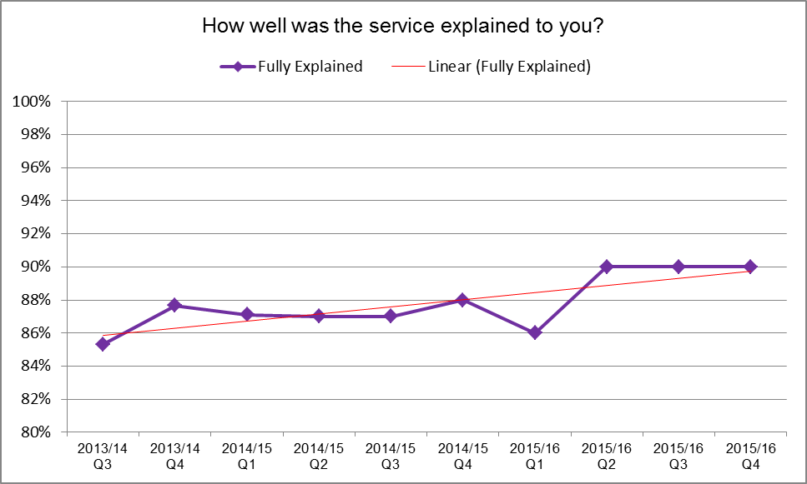
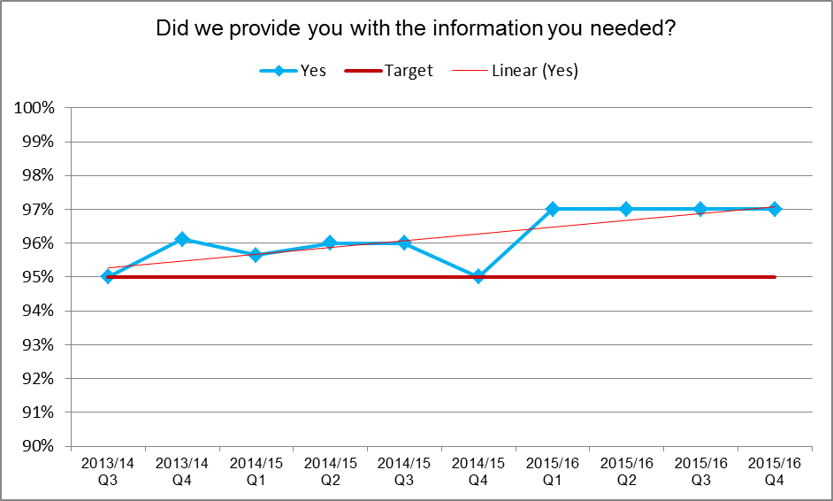
Below are some charts that show some trends and averages from the past 3 years.

