UK Stroke Assembly (South)
Monday 3 – Tuesday 4 July 2017
Radisson Blu Stansted, Essex

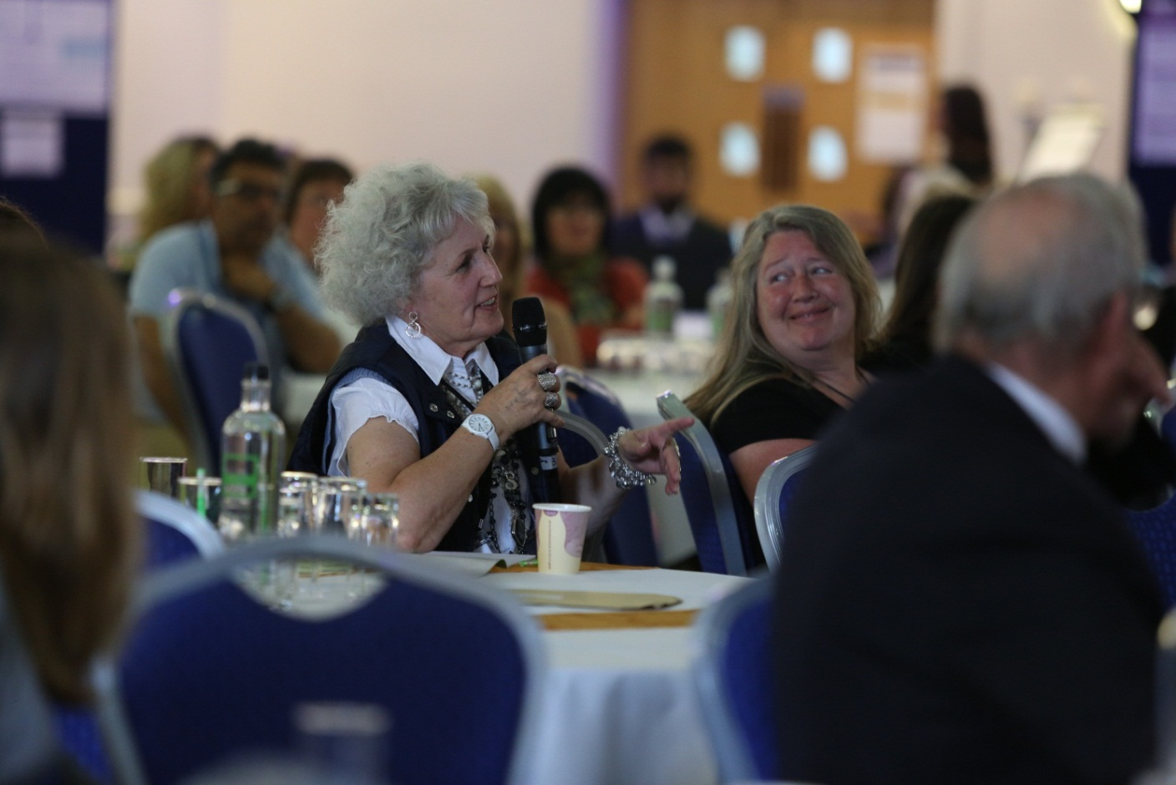

Stroke Exchange – Your Voice (optional)

We have three 30 minute slots available in our exhibition area for anyone who wants to ‘have their say’ on stroke. This is a platform to share your stroke story, your achievements in life after stroke, or inspire others how to take action on stroke.

If you would like to be considered for one 30 minute slot, tell us in writing, what you want to talk about.

Your name: _____________________________________________________________

Tell us what you want to talk about:

Send this page to info@strokeassembly.org.uk
If you have any questions call us on 01527 903 917.

Allocation of Stroke Exchange places will be confirmed in June 2017.

